**ISSUE :** [**https://github.com/appsmithorg/appsmith/issues/30475**](https://github.com/appsmithorg/appsmith/issues/30475)

**Write test cases for newer implementation #30475**

First I opened the server file in Intellij.

Next checked the files in which test cases are not written.

Then I found model package in which test cases were not

written .

I have taken reference from other test cases classes and written test cases for following model package classes :

1)ActionConfigurationTest  
2)ActionExecutionRequest  
3)ActionExecutionResult  
4)ApiKeyAuth  
5)AuthenticationResponse

I have used Junit for writing the test cases.

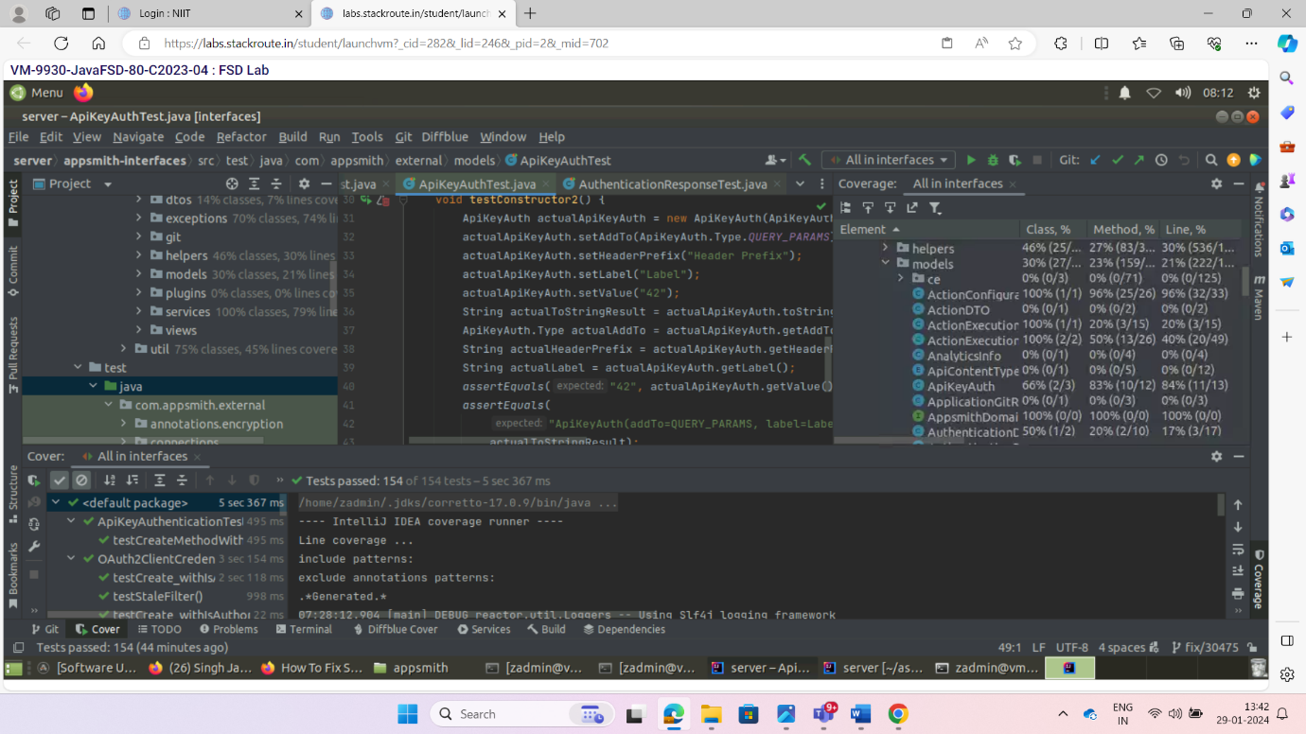

After writing the test cases, I hve pushed the code in git by using following git commands

1. Git add .
2. Git commit -m “added testcases”
3. Git push -u origin main

After this raise a pull request over appsmith github project adding description.

Below mentioned a link for pull request :

[https://github.com/appsmithorg/appsmith/pull/30698](%20https://github.com/appsmithorg/appsmith/pull/30698)